Azure HDInsight - Big data processing using Hive on Azure HDInsight

## 

## Provision HDInsight Linux Hadoop cluster with Azure Management Portal

To provision HDInsight Hadoop cluster with Azure Management Portal, perform the below steps.

1. Go to the Azure Portal portal.azure.com. Login using your azure account credentials.
2. Select **NEW -> Data Analytics -> HDInsight**

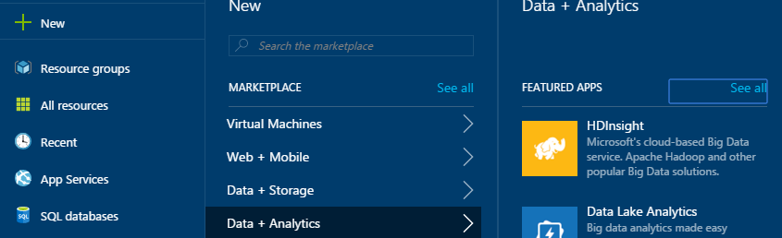

1. Enter or select the following values.
   1. **Cluster Name:** Enter the cluster name. A green tick will appear if the cluster name is available.
   2. **Cluster Type:** Select **Spark** as the cluster type.
   3. **Cluster Operating System:** Select Linux as the cluster operating system
   4. **Version:** Select **3.6** as the cluster version.
   5. **Cluster Tier:** Select the **Standard** cluster tier

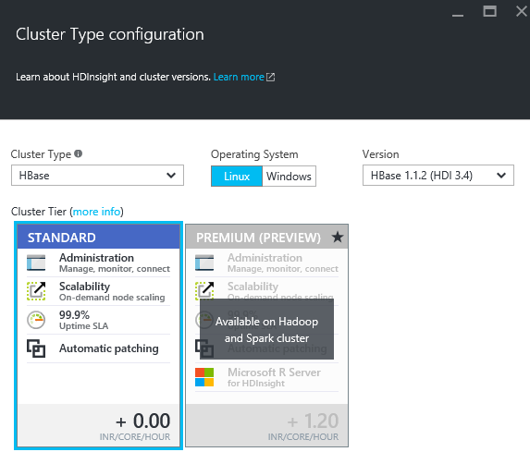

* 1. **Subscription:** Select the Azure subscription to create the cluster.
  2. **Resource Group:** Select an existing resource group or create a new resource group.
  3. **Credentials:** Configure the username and password for HDInsight cluster and the SSH connection. SSH connection is used to connect to HDInsight cluster through a SSH client such as Putty.

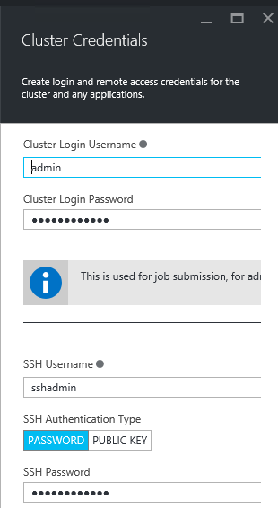

* 1. **Data Source:** Create a new storage account and a default container.

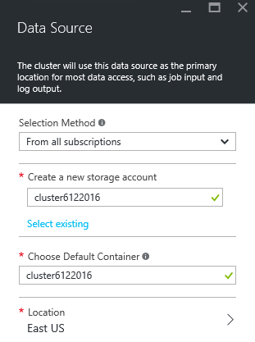

* 1. **Node Pricing Tiers:** Set the number of head node and worker nodes as shown below.

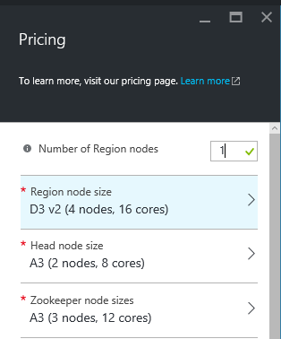

**Note:** You can select lowest pricing tier A3 nodes or reduce the number of worker nodes decrease the cluster cost.

* 1. Leave other configuration options as default and click **Create** to provision HDInsight Hadoop cluster. It will take 15-20 minutes for cluster provisioning.

**The HDInsight Linux Hadoop cluster is now ready to work with.**

## Copy lab data to the storage account

In this section, you’ll copy the files required for the lab to your storage account.

To copy the files, follow the below steps.

1. Launch Azure Storage from your cluster dashboard

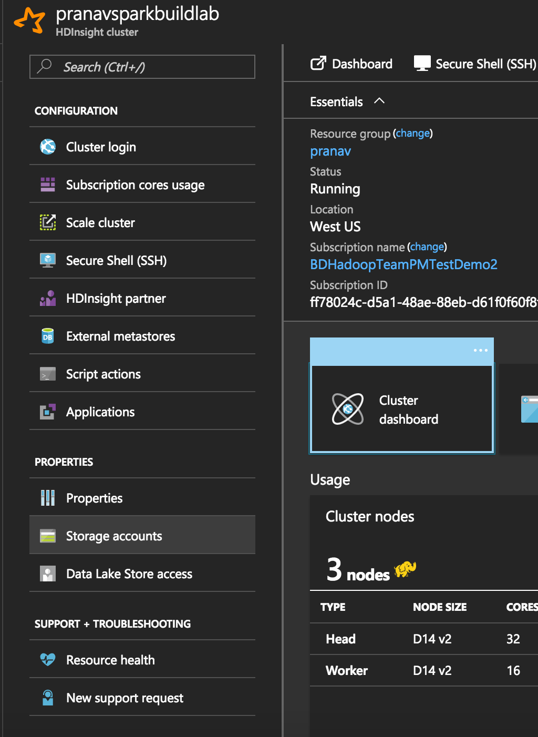

1. Select the **Blob container** for your cluster
2. Create a container called **sparklabs**
3. Navigate to **sparklabs** and create a container called **Lab03**
4. Upload SalesTransactions1.csv and SalesTransactions2.csv to Lab03. Weblogs.csv can be found in **data\sparklabs\Lab03** folder.

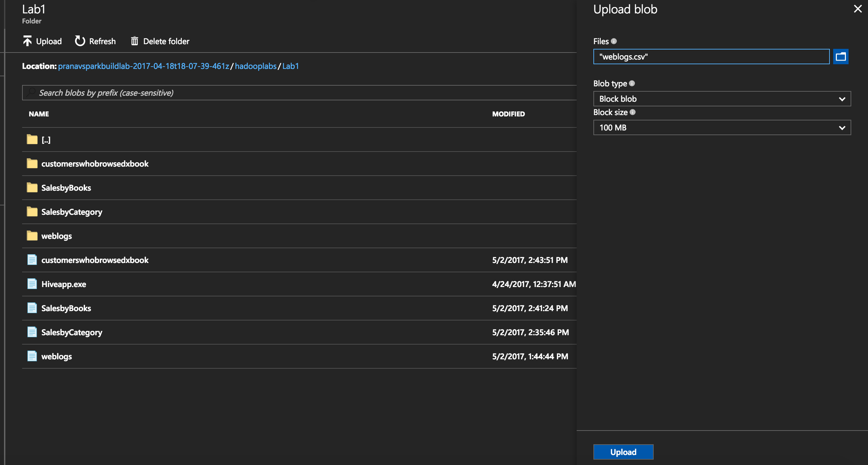

## Launching a new Jupyter Notebook

### Access Azure Portal

1. Sign in to the [Azure Portal](https://ms.portal.azure.com/).

If Spark Cluster is pinned to the “StartBoard”:

1. Click the tile for your Spark Cluster.

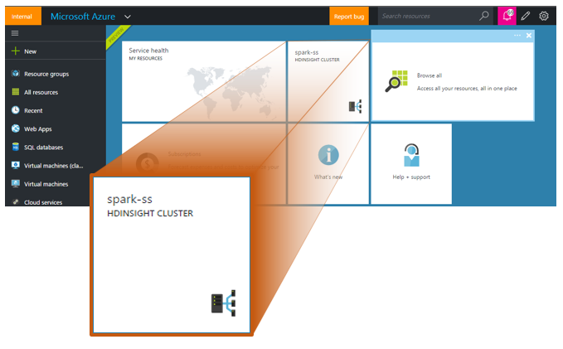

If Spark Cluster is not pinned to the “StartBoard”:

1. Click Browse, select HDInsight Clusters.

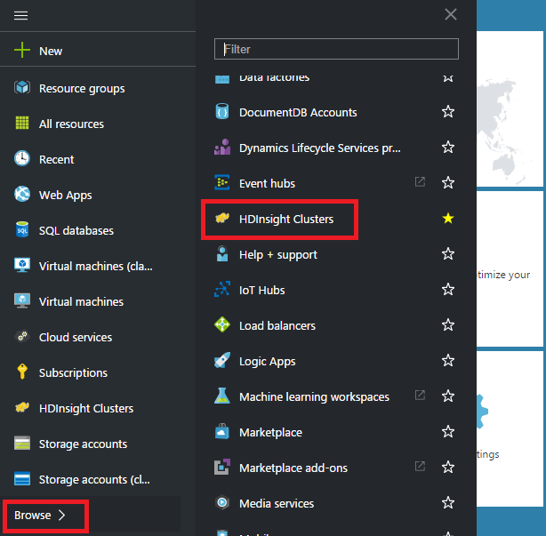

1. Select your Spark Cluster.

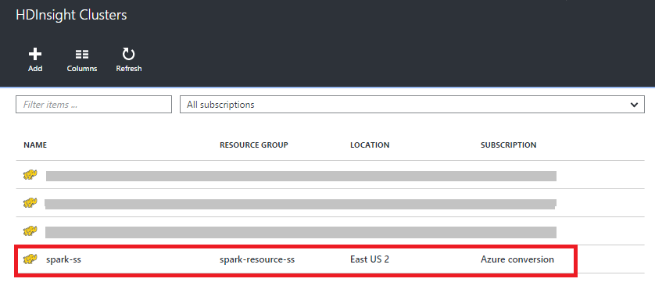

### Launch Jupyter Notebook

1. Click on Cluster Dashboards tile displayed under the Quick Links of Cluster Blade.

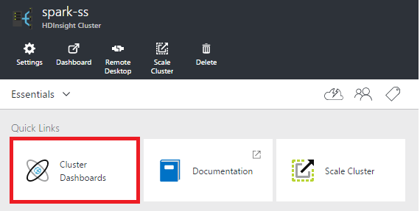

1. Locate **Jupyter Notebook** tile on Cluster Dashboards tile and click on it.

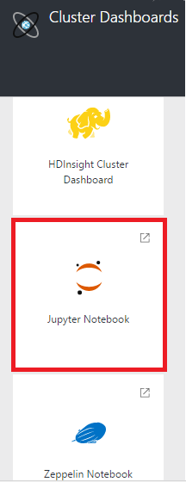

1. When prompted, enter the admin credentials for the Spark cluster.

This will open the Jupyter dashboard.

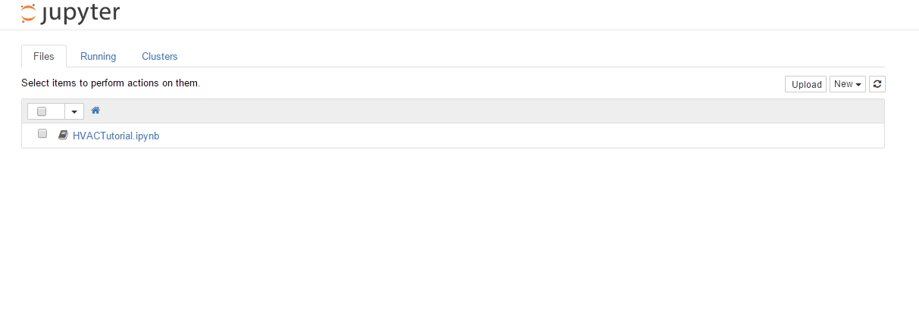

### Upload a new notebook

1. Click **Upload** dropdown button present at top right side of Jupyter Notebook screen.
2. Select a name with an ipynb extension
3. Upload and click the notebook to launch it